BIKE STATIONS ANALYSIS
Project Objectives
- Monitor Bike Availability
  - Track total bikes, available bikes, and station capacity to ensure smooth operations.
- Evaluate Station Utilization
  - Analyze how efficiently bike stations are being used using utilization metrics.
- Identify High & Low Performing Stations
  - Detect stations with high availability (surplus) and low availability (shortage).
- Analyze City-wise Performance
  - Compare bike usage and capacity across different contract locations (cities).
- Track Operational Status
  - Monitor active vs inactive stations and banking/bonus facility availability.
- Understand Time-Based Trends
  - Analyze bike availability trends across months for demand forecasting.
- Support Decision Making
  - Provide actionable insights for bike redistribution and operational improvements.
Data Model

- The data model is designed using a star schema approach, with Bike_Stations as the central fact table connected to multiple dimension tables such as station, city, date, status, banking, and bonus. All relationships are one-to-many with single-direction filtering, enabling efficient data analysis, improved performance, and scalable reporting.

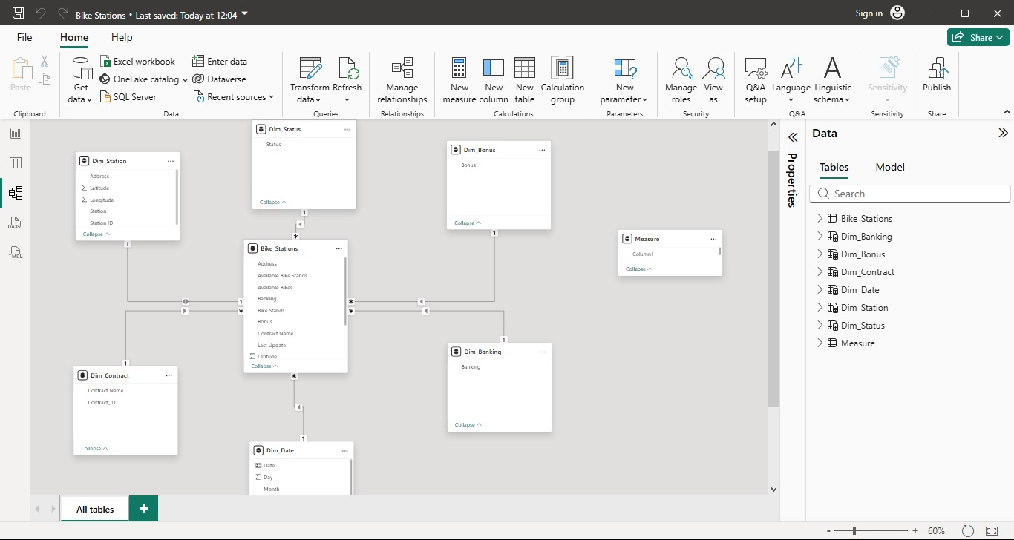

Dashboard

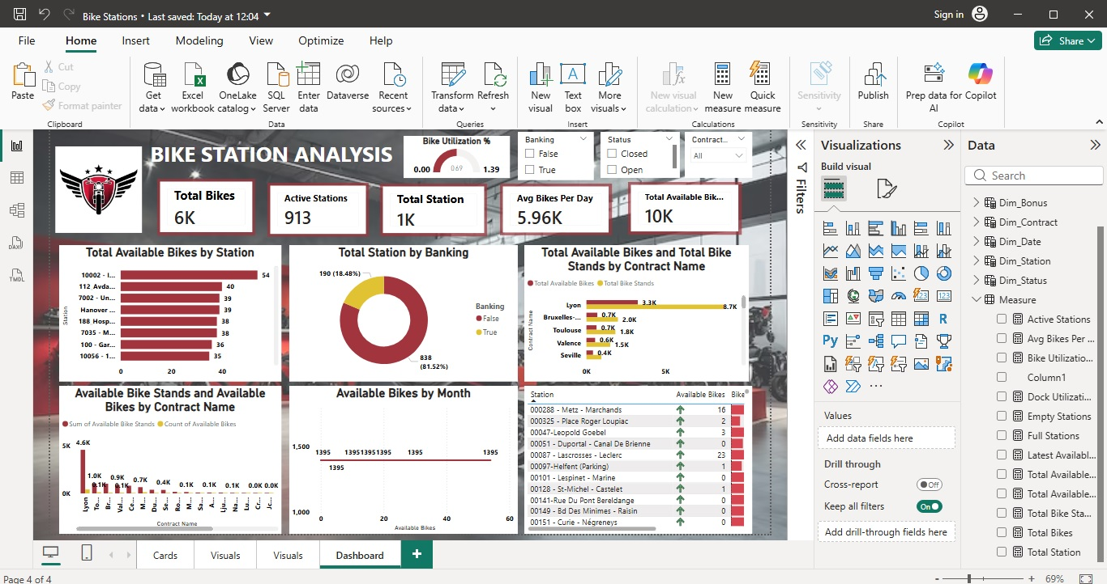

Key Insights
- The system operates with ~6K bikes across ~1K stations
- 913 stations are active, indicating strong network coverage
- Moderate utilization rate (~60–70%), suggesting optimization opportunities
- Presence of empty and full stations indicates uneven bike distribution
- Major cities (e.g., Lyon, Brussels) show higher demand and capacity
- Majority of stations are non-banking, highlighting improvement scope
- Stable trends indicate consistent demand over time

Business Recommendations
- Implement bike redistribution strategy
- Increase bikes in high-demand stations
- Reduce excess bikes in low-demand areas
- Expand banking-enabled stations
- Use real-time tracking for better operations

